

NAME: ABIGAIL WAIHENYA
ID: 669841
COURSE: SWE3090A
LECTURER: PROF FREDRICK OGORE
ASSIGNMENT: PEEREASY PROJECT FIGMA DESIGN

SIGN IN PAGE
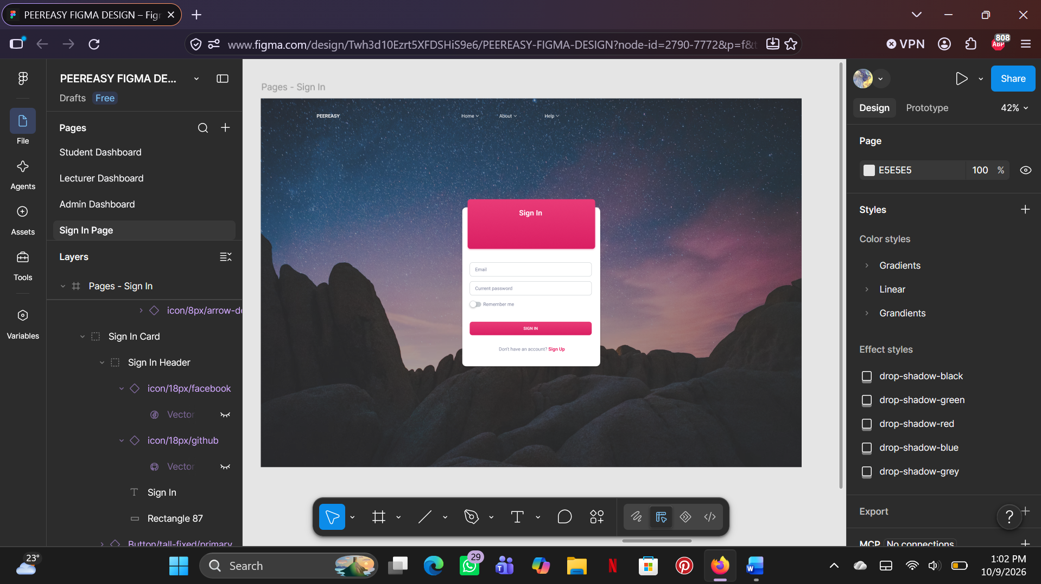

STUDENT DASHBOARD
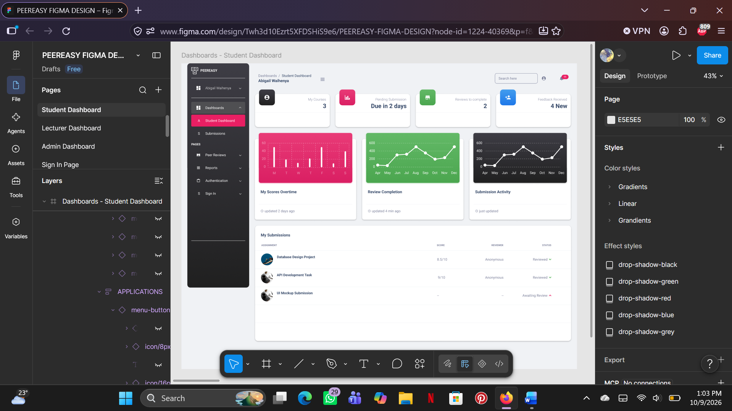

LECTURER DASHBOARD
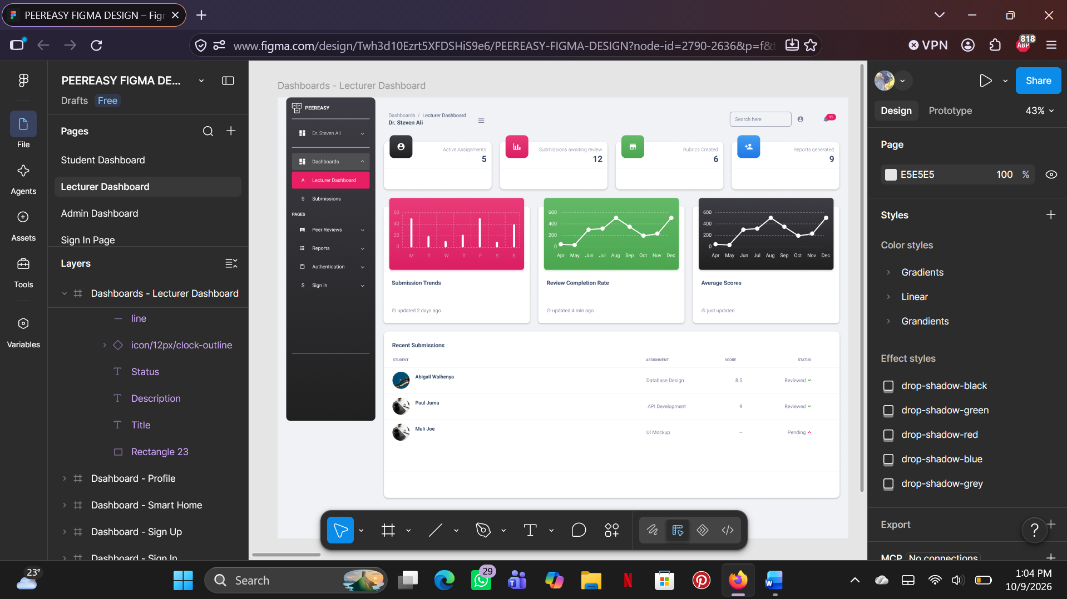

ADMIN DASHBOARD


